## STAKEHOLDER ENGAGEMENT & INVESTMENT PLAN ANNUAL REPORT 2019

#### Stakeholder Engagement

WEBG maintained the high levels of contact with local stakeholders during 2019. The Local Community Relationship Manager, Mr Aleksandar Anđić and his assistant Mr Nikola Radonjin visited the windfarm site and many of the surrounding villages several times each week. Nikola is from the village of Dolovo and his role is to provide local support and assistance with the resolution of community grievances. Nikola was employed on a temporary contract which expired in September 2019.

The WEBG team (Aleksandar Anđić, Nikola Radonjin, Jovana Mićović and Slobodan Sarajlija) held presentations in three local communities during June 2019. The date, location and purpose of the meeting was announced two weeks before the meeting (at the locations listed within the SEP). About 35 people (in total) attended these presentations. Each meeting lasted about an hour.

The purpose of these meetings was to discuss the ESHS risks and management arrangements for the operation of the windfarm. The presenters described how WTGs work, site safety, the possible impact on birds and bats (including the mortality surveys being done), and the dangers associated with the illegal burning of crop residues. The section on site safety included discussion of the risks associated with driving too fast across the sites (the recommended speed limit for cars is 40kph and 20kph for farm vehicles or trucks), ice throw and blade throw.

These topics have been summarised in a safety leaflet that has been provided to local stakeholders (see Figure 1, below). Copies of this leaflet was distributed at the stakeholder meeting.

The leaflet also includes the phone number for the Control room and the participants were encouraged to call and report any incident. The presentations were well received by the participants and there were a number of questions about the operation of the windfarm. The participants recognised the dangers associated with stubble burning.

In addition to the leaflets, WEBG have put up large information boards at each of the four entrances to the windfarm. See Figure 2 below.

Electronic copies of the leaflet and a report on presentation are available on the corporate website (<http://www.teslawind.rs/cibuk-1/documents>). Images from the presentation report are shown in Figures 3 to 7, below.

The next presentations will be held in March 2020 in three local communities, Mramorak, Dolovo and Vladimirovac. The objective of these meeting is to reinforce the message on site safety and the risks of stubble burning.

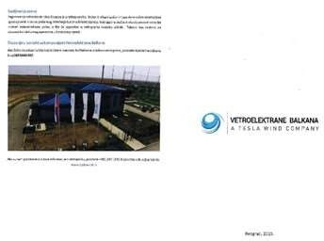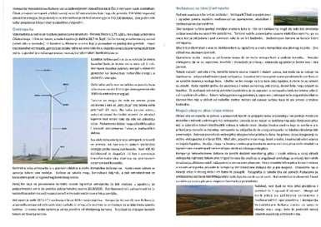

**Figure 1 – Čibuk ESHS Leaflet**

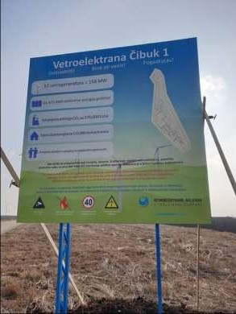**Figure 2 – ESHS Information Board at the Entrance to the Čibuk windfarm.**

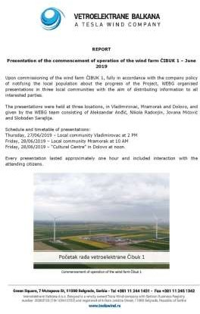

**Figure 2 – ESHS Information Board at the Entrance to the Čibuk windfarm.**

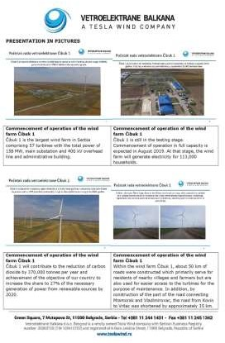

**Figures 3 and 4 – Extracts from the Stakeholder Presentations**

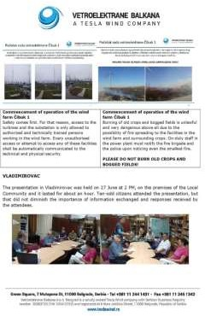

**Figures 5, 6 and 7 – Extracts from the Stakeholder Presentations**

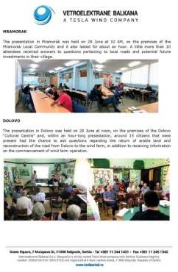

During the construction period, WEBG received 489 grievances through the CGM. The first grievance was received on 13th June 2017 and the last was received on 26th August 2019. Of these 489 grievances, only 38 were received during 2019. The majority of the 2019 claims were submitted long after the damage was caused, some to a year after the incident. The vast majority of the grievances were submitted as a consequence of machinery damage to land or crops.

All of the claims made under the CGM were resolved through mutual agreement. None of the claims submitted were referred to the local Court. All of the claims for compensation received were resolved in line with the timetable set-out in the CGM and all payments were made by the end of 2019.

In compliance with the conditions of the Construction Permit, WEBG were required to repair the road section from Dolovo to the entrance of the windfarm. This restoration work was required following the completion of the windfarm construction works. Although WEBG cannot undertake or commission the works, WEBG provided the necessary funds to the Municipality of Pančevo for the repair of Road Section 1 on 29th May 2019 with an understanding that the repair work would be completed within two months. The Municipalities’ procurement process was slow and the completion of the work by the contractor was delayed. However, the repair work to the road was finished on 24th November. The work was done to a good standard and the local stakeholders confirmed their satisfaction with the work completed (see the Figures 8 to 10, below).

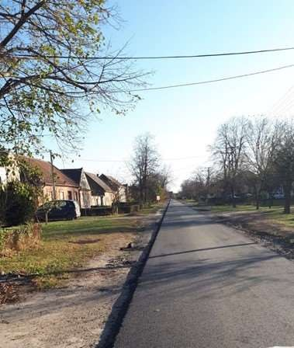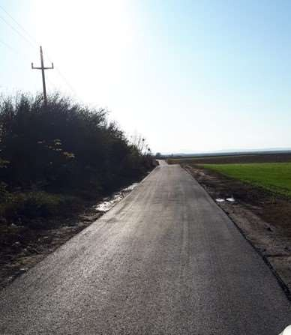

**Figure 8 – Resurfaced Road in Dolovo Figure 9 – Resurfaced Road between Dolovo**

**and the site entrance**

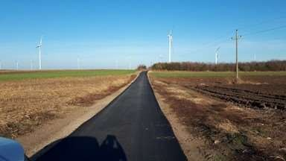

**Figure 10 – Resurfaced Road between Dolovo and the site entrance**

#### Social Investment

WEBG has continued the delivery of the Social Investment Plan and in 2019 the company:

* Donation for Elementary school ‘’Prvi maj’’ Vladimirovac for Romanian spring festival Martisor in amount of 250 euros.
* Donation for Volunteer Firefighters Association ‘’Mramorak’’ for the firefighting equipment in amount of 2,450 euros.
* Donation for the publisher ‘’Akademska misao’’ for the book ‘’Vjetroelektrane’’ written by professor Željko Đurišić, about the technology of the windfarms in amount of 2,000 euros.
* Donation for the Faculty of Electrical Engineering and for their H-Bridges team in amount of 3,600 euros. This donation is support in participation in International Future Energy Challenge Competition (IFEC).
* Donation Agreement with City of Pančevo for 4,2km of road repair in village of Dolovo. Total amount of donation is 272,000 euros. Full road repair is done complete in November 2019 from 7th of July street to the Čibuk 1 site entrance.
* Donation for B92 Foundation for the project ‘’Pčelice’’ in amount of 4,500 euros. This donation helped purchase of educational didactic equipment for 5 schools for children with special needs. The educational didactic equipment will help children master school tasks much easier.
* Donation for Women’s Association ‘’Vredne ruke Banata’’ from Vladimirovac for the ‘’Autumn festival’’ in total amount of 80 euros.

The total amount of the 2019 donations was **284,880 euros**.

During 2020 WEBG currently intend to provide more funds for educational purposes. Additional donations are being considered to support local firefighters as well as the broader communities.